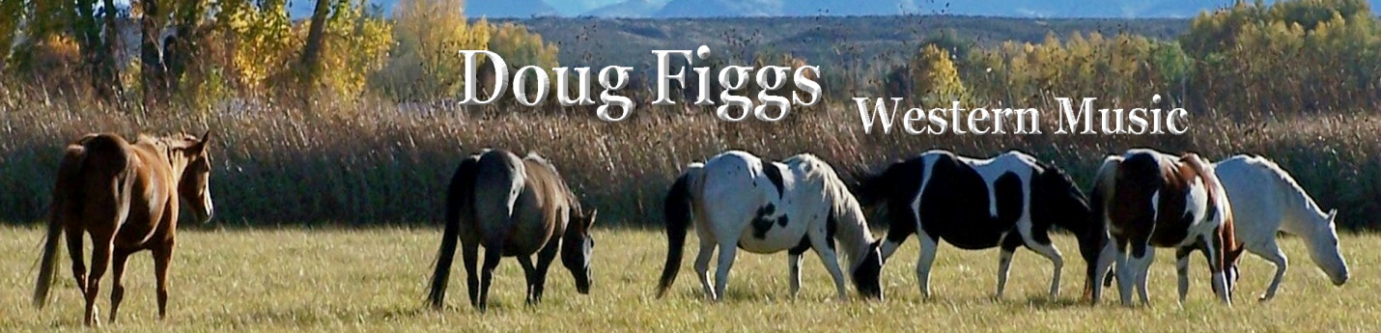

Doug Figgs Bio

Doug Figgs is a horseshoer, a working cowboy, and a Western music singer/songwriter. In twenty plus years of shoeing horses he has earned the title of “Certified Journeyman Farrier”, the highest level attainable through the American Farrier’s Association. In the last few years he has turned his attention to his love of music with the emphasis on Western themes. His 4th album, “A Cowboy Like Me” received the Rural Roots Commission’s 2016 “Traditional Western” CD of the year award. As a member of the Western Music Association he was named 2015 WMA songwriter of the year and his song “Socios” was named 2015 WMA song of the year. He received the Academy of Western Artists “Will Rogers Award” for 2015 Western Male Performer of the Year. His song “Socios” also won the Academy of Western Artists “Will Rogers Award” 2014 best Western song, and a co-write with Todd Carter “Charlie and Evangeline” won the Western Writers of America 2015 “Spur Award” for best Western song, both songs from his “Partners” CD. A third song (also from the “Partners” CD), “Running With the Wind” won the New Mexico Music Awards 2015 best Western song. He has toured the Southwest extensively and continues to turn out his own variety of Western music, from hard driving songs with a tinge of southern rock, to beautiful ballads and everything in between.

Doug Figgs P. O. box 3 Lemitar, NM 87823
505-440-0979 figgspainthorses2@yahoo.com
www.DougFiggs.com
- 2019 “New Mexico Music Awards” Best Western Song “I Make My Livin’ in the Saddle”
- 2018 IWMA “Male Performer of the Year”
- 2018 IWMA “Group of the Year” with “The Cowboy Way” trio
- 2018 “New Mexico Music Awards” Best Country CD “…thinkin’ of you”
- 2017 Western Music Association “Group of the Year” with “The Cowboy Way”
- 2017 “New Mexico Music Awards” Best Western Song “A Cowboy Like Me”
- 2017 “Wrangler Award” with the trio “The Cowboy Way”
- 2016 RRMC “Traditional Western Music” CD of the year “A Cowboy Like Me”
- 2015 Academy of Western Artists “Will Rogers Award” Western Male Performer
- 2015 Western Music Association “Songwriter of the Year”
- 2015 Western Music Association “Song of the Year”…….”Socios”
- 2015 “New Mexico Music Awards” Best Western Song “Running With the Wind”
- 2015 WWA “Spur Award” Best Western Song “Charlie and Evangeline”
- 2014 Academy of Western Artists “Will Rogers Award” Western Song “Socios”
- 2014 WMA “Harmony Trio Award” winner with the trio “The Cowboy Way”

"Doug Figgs is a western entertainer that delivers a true taste of the West with his
soothing voice, warm personality and exceptional song-writing. He well represents
the rising talent in western music."
Mary Kaye
“For several years now I have enjoyed listening to Doug’s recordings and live performances. He’s an excellent songwriter, picker and singer whose poignant western songs stem from his cowboy lifestyle in New Mexico. He’s a Spur Award winner for good reason. His songs tell vivid stories from the frontier and the modern day west. Though Doug is quickly becoming a favorite on the western music scene, his tunes transcend all genres. I can’t imagine who wouldn’t enjoy listening to a Doug Figgs song!”
Mike Blakely

"A key element in the believability of any Western/Cowboy music performer is the genuineness of that performer, and in Doug Figgs, I saw not only a genuine performer, genuine singer, but a genuine Westerner who's experience and lifetime of work with cattle and horses gives him a realism that is wonderfully apparent. His guitar playing and singing are solid and confident, and he portrays what those of us in Western music hope to preserve and promote. I heartily endorse Doug as the real deal in Western Music!”
Juni Fisher

